Project
  - Deadline: Phase 1 (Mid project Progress Report) 26/07/2026 @ 23:59 Phase 2 (Final project Report) 9/8/2026 @ 23:59
[Total Mark is 20]

System Analysis and Design
IT-353

Instructions:
- You must submit two separate copies (one Word file and one PDF file) using the Assignment Template on Blackboard via the allocated folder. These files must not be in compressed format.
- It is your responsibility to check and make sure that you have uploaded both the correct files.
- Zero mark will be given if you try to bypass the SafeAssign (e.g. misspell words, remove spaces between words, hide characters, use different character sets, convert text into image or languages other than English or any kind of manipulation).
- Email submission will not be accepted.
- You are advised to make your work clear and well-presented. This includes filling your information on the cover page.
- You must use this template, failing which will result in zero mark.
- You MUST show all your work, and text must not be converted into an image, unless specified otherwise by the question.
- Late submission will result in ZERO mark.
- The work should be your own, copying from students or other resources will result in ZERO mark.
- Use Times New Roman font for all your answers.
Student Details: CRN:
Name: Jana Abdullah Jaber Zahrani  Name:  Name:  Name:  Name: |  | ID: S240041830  ID:  ID:  ID:  ID:

Project submission guidelines and instructions
- Mid project Progress Report:
Students are required to submit a short mid progress report, which must include:
  - Work completed this period
  - One key decision has been made during this period
  - One problem encountered
  - Plan to do next.
  - Each group member input/participation.
  - A link to each group member GitHub repository
- Version History / Commit Log Requirements:
Each group member must complete and submit project history/timestamp using a live, editable GitHub link. The repository must show commit history reflecting incremental progress. commit regularly (at minimum once per week), with clear, descriptive commit messages.
A separate section in the report must be added and named “Project Artifacts" to include each student’s name and a link to his/her GitHub repository (with commit history).
What NOT to do: Students must not write their report elsewhere and paste the final version in at the last minute. They also should not make a single commit containing your entire files. Both are treated as red flags regardless of the quality of the final work.
- Written Reflection (End of Project Report):
The project report should include a Reflection section (300–500 words) as the last section (one section for each student). This section must be written in students’ own words and should address some of the following:
  - Describe one specific challenge or obstacle you encountered during this project and explain in detail how you identified and resolved it.
  - Explain why you chose your specific approach/method/model over at least one alternative you considered, and what tradeoffs informed that decision.
  - If you used any AI tools during this project (e.g., ChatGPT, Claude, Copilot), disclose which tool(s), for what specific purpose (e.g., debugging, grammar checking, brainstorming), and how you verified or modified the output.
  - What would you do differently if you were to redo this project with more time or resources?

Important Notes
- AI use: Students may use AI tools (ChatGPT, Claude, Copilot, Gemini, etc.) only for brainstorming approaches, debugging small errors, or proofreading text. AI must not be used to generate analysis, write code logic, or produce substantial portions of report or codebase. Any permitted AI use must be disclosed in Reflection section. Undisclosed AI use, or AI use beyond this scope (disclosed or not), will result in a zero grade for the entire project.
- Any submission lacking a valid, inspectable version/commit history, or showing evidence of AI generation or plagiarism, will receive a zero grade for the entire project.
- Failure to submit mid progress reports as required, or submission of reports found to be fabricated, copied, or AI-generated, will result in a zero grade for the entire project.

Project Rubric

Component | Weight | Note
Final report/deliverable | 85% | Core assessment of the work itself.
Mid Progress report | 10% | Incentivizes engagement across the timeline, not just at the end. Absence blocks credit for the whole project.
Version/commit history | Pass/fail | Not a grade component. Absence blocks credit for the whole project.
Reflection section | 5% | Rewards demonstrated understanding and honest disclosure.

Scenario

The Saudi Electronic University (SEU) currently organizes a wide variety of extracurricular activities, including workshops, seminars, competitions, volunteering opportunities, social events, career development sessions, and sports activities. However, information about these activities is scattered across emails, social media platforms, and announcements, making it difficult for students to discover upcoming events and register for them. Activity organizers also face challenges in managing registrations, tracking attendance, monitoring participation limits, and preparing reports.
Learning Outcome(s):
Illustrate most common analysis and design techniques in the form of a group project.

To address these issues, SEU plans to develop a Student Activities Management System (SAMS) that will provide a centralized platform for managing all student activities. The proposed system should allow students to browse available activities by category, campus, or date, view detailed information about each activity, reserve a seat, cancel a reservation before the registration deadline, receive notifications and reminders, and record their attendance by scanning a QR code or using another electronic attendance method at the event. Students should also be able to view their personal activity history throughout their studies, including the number of activities attended, participation hours, certificates earned, and achievements. Upon graduation, the system should automatically generate a comprehensive Student Activity Report (Activity Transcript) summarizing all extracurricular activities completed during the student's academic journey.
Activity organizers should be able to create, edit, publish, and cancel activities, define participant limits, registration periods, locations (physical or virtual), attendance methods, and eligibility requirements. Organizers should also manage participant lists, approve registrations when required, record attendance, issue participation certificates, and generate reports on attendance rates and student engagement.
The Student Affairs Department should oversee the entire system by managing activity categories, approving activities submitted by organizers, monitoring participation statistics across all university branches, generating institutional reports, and ensuring that each student's activity transcript is accurate and complete before graduation.
The system should also support notifications for registration confirmations, activity reminders, cancellations, and waitlist updates. If an activity reaches its maximum capacity, additional students should automatically be placed on a waiting list and promoted when vacancies become available.
The university expects the new system to improve student engagement, simplify activity management, eliminate manual attendance tracking, and provide accurate records of students' extracurricular involvement throughout their university studies.
Based on the above scenario, complete the following tasks.

Task 1
Develop a Gantt Chart for the project, including major development activities, durations, and dependencies. [1.5 marks]
WBS Code | Task Name | Start Date | End Date | Dependencies
1.0 | Requirements & System Design | 23/07/2026 | 12/08/2026
1.1 | Requirement gathering (Students, Organizers, Student Affairs) | 23/07/2026 | 30/07/2026 | None
1.2 | System Architecture & Database Design | 31/07/2026 | 06/08/2026 | 1.1
1.3 | UI/UX Wireframes & Prototype Design | 07/08/2026 | 12/08/2026 | 1.2
2.0 | System Core Development | 13/08/2026 | 23/09/2026
2.1 | Student Portal (Browsing, Registration, Waitlists, History) | 13/08/2026 | 27/08/2026 | 1.3
2.2 | Organizer Portal (Event creation, approvals, participant limits) | 28/08/2026 | 10/09/2026 | 2.1
2.3 | Student Affairs Admin Module (Approvals, categories, metrics) | 11/09/2026 | 23/09/2026 | 2.2
3.0 | Special Features & Modules | 24/09/2026 | 15/10/2026
3.1 | QR Code Attendance & Tracking Engine | 24/09/2026 | 01/10/2026 | 2.1, 2.2
3.2 | Automated Notifications Engine (Reminders, Waitlist status) | 02/10/2026 | 08/10/2026 | 2.1
3.3 | Certificates & Activity Transcript Generation Engine | 09/10/2026 | 15/10/2026 | 2.3
4.0 | Testing & Quality Assurance | 16/10/2026 | 29/10/2026
4.1 | System Integration & Performance Testing | 16/10/2026 | 22/10/2026 | 3.1, 3.2, 3.3
4.2 | User Acceptance Testing (UAT with Student Affairs) | 23/10/2026 | 29/10/2026 | 4.1
5.0 | Deployment & Training | 30/10/2026 | 12/11/2026
5.1 | User Training (Organizers & Admin Staff) | 30/10/2026 | 05/11/2026 | 4.2
5.2 | Final Production Deployment & Launch | 06/11/2026 | 12/11/2026 | 5.1

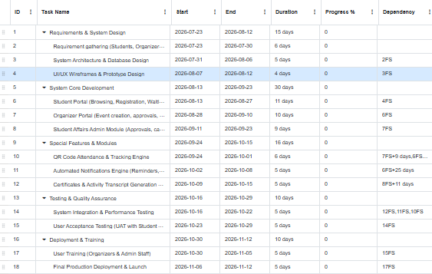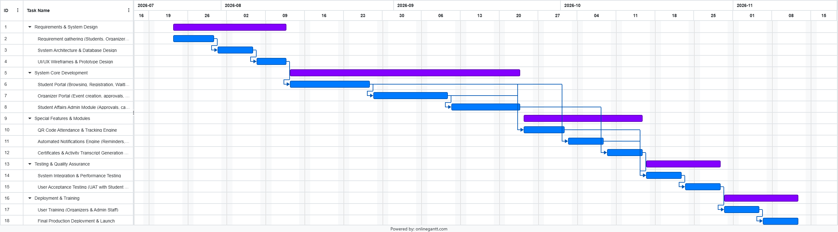

Task 2
Select ONE prototyping approach (Evolutionary Prototyping or Throwaway Prototyping). Develop low-fidelity prototypes for 3 main screens of the system and justify why your chosen approach is more appropriate for this project. [2 marks]

Task 3
Develop the Data Flow Diagrams (DFDs):
- Context Diagram
- Level-0 DFD
- Three Level-1 DFD for 3 major processes [2.5 marks]

Task 4
Develop the Use Case Model:
- Identify all system actors.
- Create one complete Use Case Diagram.
- Fully document three use cases using the use case template. [3 marks]

Task 5
Develop two UML Activity Diagrams for two major business processes. [2 marks]

Task 6
Develop a UML Class Diagram including classes, attributes, methods, associations, multiplicities, and inheritance where appropriate. [3 marks]

Task 7
Design the relational database, including tables, primary keys, foreign keys, appropriate data types, and normalization (up to at least Third Normal Form). [3 marks]

